Prerequisites 3
Installing the Tutorial Sample Code 3
Setting Up the Emulator 4
Setting Up the Projects 4
Adding the test case class file 10
Adding the test case constructor 11
Adding an initial conditions test 14
Adding a UI test 15

http://developer.android.com/tools/testing/activity_test.html

Android includes powerful tools for testing applications. The tools extend JUnit with additional features, provide convenience classes for mock(模拟) Android system objects, and use instrumentation to give you control over your main application while you are testing it(提供了指令，让你在测试应用的时候，可以控制应用。意思是，在执行测试的时候，你可以操控应用，这样测试就可以检测应用的操作). The entire Android testing environment is discussed in the document Testing Fundamentals.

The Android testing tools---Android测试工具
a simple Android application---use a test application to test the simple Android application.

涉及到的基本概念
an application under test and a test application
- 一个Android测试，它本身就是一个Android应用
- test case--Android测试的组成元素；继承JUnit的TestCase 类
- 根据你要测试的Android组件，选择对应的Android test case class
- Android测试的种类：1)应用的初始化测试(明确应用是否按照预期的进行初始化)
- UI操作测试---自动化的UI测试，利用指令，测试应用发送事件到被测应用
- 测试状态管理---用来测试管理状态的代码

This tutorial demonstrates the Android testing tools by presenting a simple Android application and then leading you step-by-step through the creation of a test application for it. The test application demonstrates these key points:

- An Android test is itself an Android application that is linked to the application under test by entries in its AndroidManifest.xml file.
- Instead of Android components, an Android test application contains one or more test cases. Each of these is a separate class definition.

- Android test case classes extend the JUnit TestCase class.
- Android test case classes for activities extend JUnit and also connect you to the application under test with instrumentation. You can send keystroke or touch events directly to the UI.
- You choose an Android test case class based on the type of component (application, activity, content provider, or service) you are testing.
- Additional test tools in Eclipse/ADT provide integrated support for creating test applications, running them, and viewing the results.
The test application contains methods that perform the following tests:
- Initial conditions test. Tests that //the application under test //initializes correctly. This is also a unit test of the application's onCreate() method. Testing initial conditions //also provides a confidence measure for subsequent tests.
- UI test. Tests that the main UI operation works correctly. This test demonstrates the instrumentation features available in activity testing. It shows that you can automate UI tests by sending key events from the test application to the main application.
- State management tests. Test the application's code for saving state. This test demonstrates the instrumentation features of the test runner, which are available for testing any component.

Prerequisites

The instructions and code in this tutorial depend on the following:
- Basic knowledge of Android programming. If you haven't yet written an Android application, do the class Building Your First App. If you want to learn more about Spinner, the application under test, then you might want to review the "Spinner" sample app.
- Some familiarity with the Android testing framework and concepts. If you haven't explored Android testing yet, start by reading the Testing Fundamentals guide.
- Eclipse with ADT. This tutorial describes how to set up and run a test application using Eclipse with ADT. If you haven't yet installed Eclipse and the ADT plugin, follow the steps in Installing the SDK to install them before continuing. If you are not developing in Eclipse, you will find instructions for setting up and running the test application in the appendix of this document.

Installing the Tutorial Sample Code

During this tutorial, you will be working with sample code that is provided as part of the downloadable Samples component of the SDK. Specifically, you will be working with a pair of related sample applications — an application under test and a test application:
- Spinner is the application under test. This tutorial focuses on the common situation of writing tests for an application that already exists, so the main application is provided to you.
- SpinnerTest is the test application. In the tutorial, you create this application step-by-step. If you want to run quickly through the tutorial, you can install the completed SpinnerTest application first, and then follow the text. You may get more from the tutorial, however, if you create the test application as you go. The instructions for installing the completed test application are in the section Installing the Completed Test Application File.
The sample applications are described in more detail in the Samples topic. Follow the instructions to download the version of the samples that's appropriate for the platform you're working with.

Setting Up the Emulator

In this tutorial, you will use the Android emulator to run applications. The emulator needs an Android Virtual Device (AVD) with an API level equal to or higher than the one you set for the projects in the previous step. To find out how to check this and create the right AVD if necessary, see Creating an AVD.
As a test of the AVD and emulator, run the SpinnerActivity application in Eclipse with ADT. When it starts, click the large downward-pointing arrow to the right of the spinner text. You see the spinner expand and display the title "Select a planet" at the top. Click one of the other planets. The spinner closes, and your selection appears below it on the screen.

Setting Up the Projects

When you are ready to get started with the tutorial, begin by setting up Eclipse projects for both Spinner (the application under test) and SpinnerTest (the test application).
You'll be using the Spinner application as-is, without modification, so you'll be loading it into Eclipse as a new Android project from existing source. In the process, you'll be creating a new test project associated with Spinner that will contain the SpinnerTest application. The SpinnerTest application will be completely new and you'll be using the code examples in this tutorial to add test classes and tests to it.

To install the Spinner app in a new Android project from existing source, following these steps:
- In Eclipse, select File > New > Project > Android > Android Project, then click Next. The New Android Project dialog appears.
- In the Project name text box, enter "SpinnerActivity". The Properties area is filled in automatically.
- In the Contents area, set "Create project from existing source".
- For Location, click Browse, navigate to the directory <SDK_path>/samples/android-8/Spinner, then click Open. The directory name <SDK_path>/samples/android-8/Spinner now appears in the Location text box.
- In the Build Target area, set a API level of 3 or higher. If you are already developing with a particular target, and it is API level 3 or higher, then use that target.
- In the Properties area, in the Min SDK Version:, enter "3".
- You should now see these values:
  - Project Name: "SpinnerActivity"
  - Create project from existing source: set
  - Location: "<SDK_path>/samples/android-8/Spinner"
  - Build Target: "API level of 3 or higher" (Target Name "Android 1.5 or higher")
  - Package name: (disabled, set to "com.android.example.spinner")
  - Create Activity: (disabled, set to ".SpinnerActivity")
  - Min SDK Version: "3"
The following screenshot summarizes these values:
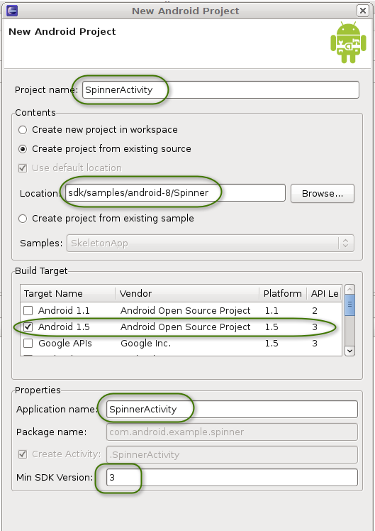
To create a new test project for the SpinnerTest application, follow these steps:
- Click Next. The New Android Test Project dialog appears.
- Set "Create a Test Project".
- Leave the other values unchanged. The result should be:
  - Create a Test Project: checked
  - Test Project Name: "SpinnerActivityTest"
  - Use default location: checked (this should contain the directory name "workspace/SpinnerActivityTest").
  - Build Target: Use the same API level you used in the previous step.
  - Application name: "SpinnerActivityTest"
  - Package name: "com.android.example.spinner.test"
  - Min SDK Version: "3"
The following screenshot summarizes these values:
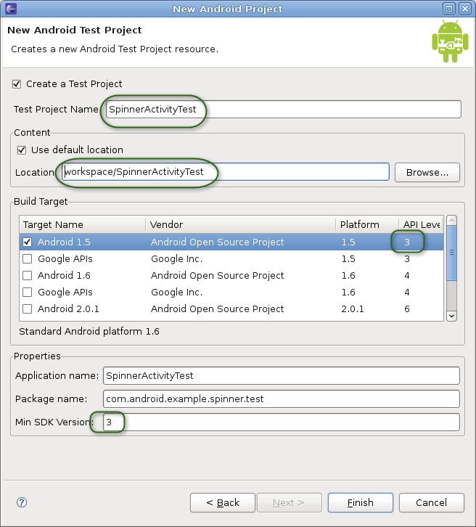
4. Click Finish. Entries for SpinnerActivity and SpinnerActivityTest should appear in the Package Explorer.
Note: If you set Build Target to an API level higher than "3", you will see the warning "The API level for the selected SDK target does not match the Min SDK version". You do not need to change the API level or the Min SDK version. The message tells you that you are building the projects with one particular API level, but specifying that a lower API level is required. This may occur if you have chosen not to install the optional earlier API levels.
If you see errors listed in the Problems pane at the bottom of the Eclipse window, or if a red error marker appears next to the entry for SpinnerActivity in the Package Explorer, highlight the SpinnerActivity entry and then selectProject > Clean. This should fix any errors.

You now have the application under test in the SpinnerActivity project, and an empty test project in SpinnerActivityTest. You may notice that the two projects are in different directories, but Eclipse with ADT handles this automatically. You should have no problem in either building or running them.

Notice that Eclipse and ADT have already done some initial setup for your test application. Expand the SpinnerActivityTest project, and notice that it already has an Android manifest file AndroidManifest.xml. Eclipse with ADT created this when you added the test project. Also, the test application is already set up to use instrumentation. You can see this by examining AndroidManifest.xml. Open it, then at the bottom of the center pane click AndroidManifest.xml to display the XML contents:
<?xml version="1.0" encoding="utf-8"?>
<manifest xmlns:android="http://schemas.android.com/apk/res/android"
package="com.android.example.spinner.test"
android:versionCode="1"
android:versionName="1.0">
<uses-sdk android:minSdkVersion="3" />
<instrumentation
android:targetPackage="com.android.example.spinner"
android:name="android.test.InstrumentationTestRunner" />
<application android:icon="@drawable/icon" android:label="@string/app_name">
<uses-library android:name="android.test.runner" />
...
</application>
</manifest>
Notice the <instrumentation> element. The attribute android:targetPackage="com.android.example.spinner" tells Android that the application under test is defined in the Android package com.android.example.spinner. Android now knows to use that package's AndroidManifest.xml file to launch the application under test. The <instrumentation>element also contains the attribute android:name="android.test.InstrumentationTestRunner", which tells Android instrumentation to run the test application with Android's instrumentation-enabled test runner.

Creating the Test Case Class

You now have a test project SpinnerActivityTest, and the basic structure of a test application also called SpinnerActivityTest. The basic structure includes all the files and directories you need to build and run a test application, except for the class that contains your tests (the test case class).
The next step is to define the test case class. In this tutorial, you'll be creating a test case class that includes:
- Test setup. This use of the JUnit setUp() method demonstrates some of the tasks you might perform before running an Android test.----create a clean test environment
- Testing initial conditions. This test demonstrates a good testing technique. It also demonstrates that with Android instrumentation //you can look at the application under test before the main activity starts. The test checks that the application's important objects have been initialized. If the test fails, you then know that any other tests against(依靠) the application are unreliable, since the application was running in an incorrect state.----ready to be tested
Note: The purpose of testing initial conditions //is not the same as using setUp(). The JUnit setUp() runs once before each test method, and its purpose is to create a clean test environment. The initial conditions test runs once, and its purpose is to verify that the application under test is ready to be tested.
- Testing the UI. This test shows how to control the main application's UI with instrumentation, a powerful automation feature of Android testing.
- Testing state management. This test shows some techniques for testing how well the application maintains state in the Android environment. Remember that to provide a satisfactory user experience, your application must never lose its current state, even if it's interrupted by a phone call or destroyed because of memory constraints. The Android activity lifecycle provides ways to maintain state, and the SpinnerActivity application uses them. The test shows the techniques for verifying that they work.
Android tests are contained in a special type of Android application that contains one or more test class definitions. Each of these contains one or more test methods that do the actual tests. In this tutorial, you will first add a test case class, and then add tests to it.

You first choose an Android test case class to extend. You choose from the base test case classes according to the Android component you are testing and the types of tests you are doing. In this tutorial, the application under test has a single simple activity, so the test case class will be for an Activity component. Android offers several, but the one that tests in the most realistic environment is ActivityInstrumentationTestCase2, so you will use it as the base class. Like all activity test case classes, ActivityInstrumentationTestCase2 offers convenience methods for interacting directly with the UI of the application under test.

Adding the test case class file
To add ActivityInstrumentationTestCase2 as the base test case class, follow these steps:
- In the Package Explorer, expand the test project SpinnerActivityTest if it is not open already.
- Within SpinnerActivityTest, expand the src/ folder and then the package marker for com.android.example.spinner.test. Right-click on the package name and select New > Class:
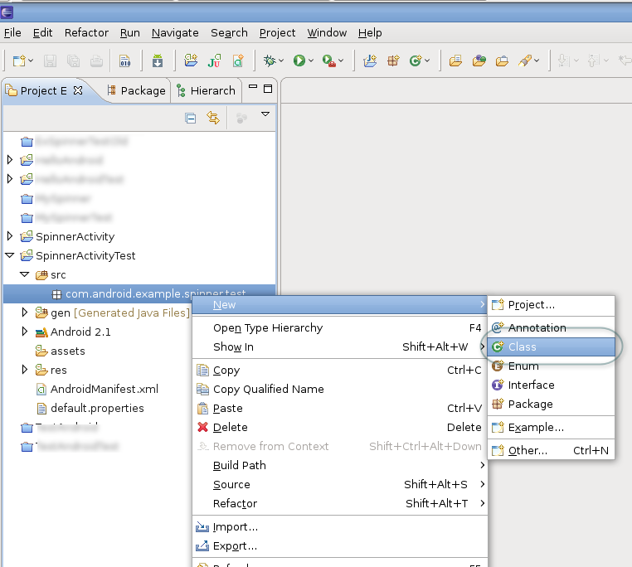
The New Java Class wizard appears:
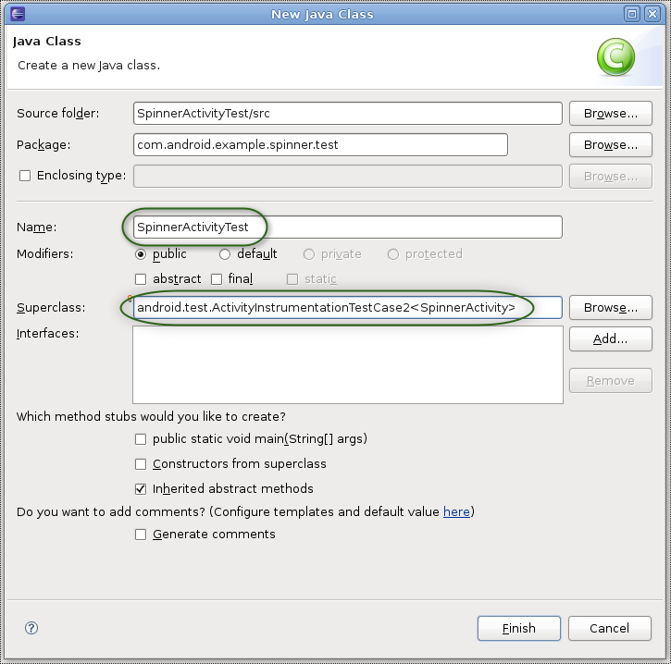
3. In the wizard, enter the following:
  - Name: "SpinnerActivityTest". This becomes the name of your test class.
  - Superclass: "android.test.ActivityInstrumentationTestCase2<SpinnerActivity>". The superclass is parameterized, so you have to provide it your main application's class name.
Do not change any of the other settings. Click Finish.
4. You now have a new file SpinnerActivityTest.java in the project.
5.To resolve the reference to SpinnerActivity, add the following import:
import com.android.example.spinner.SpinnerActivity;

Adding the test case constructor
To ensure that the test application is instantiated correctly, you must set up a constructor //that the test runner will call// when it instantiates your test class. This constructor has no parameters, and its sole(基本) purpose is to pass information to the superclass's default constructor. To set up this constructor, enter the following code in the class:
public SpinnerActivityTest() {
super("com.android.example.spinner", SpinnerActivity.class);
} // end of SpinnerActivityTest constructor definition
This calls the superclass constructor with the Android package name (com.android.example.spinner)and main activity's class (SpinnerActivity.class) for the application under test. Android uses this information to find the application and activity to test.
You are now ready to add tests, by adding test methods to the class.

Adding the setup method
The setUp() method is invoked before every test. You use it to initialize variables and clean up from previous tests. You can also use the JUnit tearDown() method, which runs after every test method. The tutorial does not use it.
The method you are going to add does the following:
- super.setUp(). Invokes the superclass constructor for setUp(), which is required by JUnit.
- Calls setActivityInitialTouchMode(false). This turns off touch mode in the device or emulator. If any of your test methods send key events to the application, you must turn off touch mode before you start any activities; otherwise, the call is ignored.
- Stores references to system objects. Retrieves and stores a reference to the activity under test, the Spinner widget used by the activity, the SpinnerAdapter that backs the widget, and the string value of the selection that is set when the application is first installed. These objects are used in the state management test. The methods invoked are:
  - getActivity(). Gets a reference to the activity under test (SpinnerActivity). This call also starts the activity if it is not already running.
  - findViewById(int). Gets a reference to the Spinner widget of the application under test.
  - getAdapter(). Gets a reference to the adapter (an array of strings) backing the spinner.
Add this code to the definition of SpinnerActivityTest, after the constructor definition:
@Override
protected void setUp() throws Exception {
super.setUp();

setActivityInitialTouchMode(false);

mActivity = getActivity();

mSpinner =
(Spinner) mActivity.findViewById(
com.android.example.spinner.R.id.Spinner01
);

mPlanetData = mSpinner.getAdapter();

} // end of setUp() method definition
Add these members to the test case class:
private SpinnerActivity mActivity;
private Spinner mSpinner;
private SpinnerAdapter mPlanetData
Add these imports:
import android.widget.Spinner;
import android.widget.SpinnerAdapter;

You now have the complete setUp() method.

Adding an initial conditions test
The initial conditions test verifies that the application under test is initialized correctly. It is an illustration(说明) of the types of tests you can run, so it is not comprehensive. It verifies the following:
- The item select listener is initialized. This listener is called when a selection is made from the spinner.
- The adapter that provides values to the spinner is initialized.
- The adapter contains the right number of entries.
The actual initialization of the application under test is done in setUp(), which the test runner calls automatically before every test. The verifications are done with JUnit Assert calls. As a useful convention, the method name is testPreConditions():
public void testPreConditions() {
assertTrue(mSpinner.getOnItemSelectedListener() != null);
assertTrue(mPlanetData != null);
assertEquals(mPlanetData.getCount(),ADAPTER_COUNT);
} // end of testPreConditions() method definition
Add this member:
public static final int ADAPTER_COUNT = 9;

Adding a UI test
Now create a UI test that selects an item from the Spinner widget. The test sends key events to the UI with key events. The test confirms that the selection matches the result you expect.
This test demonstrates //the power of using instrumentation in Android testing. Only an instrumentation-based test class //allows you to send key events (or touch events) to the application under test. With instrumentation, you can test your UI without having to take screenshots, record the screen, or do human-controlled testing.

To work with the spinner, the test has to request focus for it and then set it to a known position. The test uses requestFocus() and setSelection() to do this. Both of these methods interact with a View in the application under test, so you have to call them in a special way.

Code in a test application that interacts with a View of the application under test must run in the main application's thread, also known as the UI thread. To do this, you use the Activity.runOnUiThread() method. You pass the code to runOnUiThread() in an anonymous Runnable object. To set the statements in the Runnable object, you override the object's run() method.
To send key events to the UI of the application under test, you use the sendKeys() method. This method does not have to run on the UI thread, since Android uses instrumentation to pass the key events to the application under test.

The last part of the test //compares the selection //made by sending the key events to a pre-determined value. This tests //that the spinner is working as intended.
The following sections show you how to add the code for this test.
- Get focus and set selection. Create a new method public void testSpinnerUI(). Add code to request focus for the spinner and set its position to default or initial position, "Earth". This code is run on the UI thread of the application under test:
public void testSpinnerUI() {
mActivity.runOnUiThread(
new Runnable() {
public void run() {
mSpinner.requestFocus();
mSpinner.setSelection(INITIAL_POSITION);
} // end of run() method definition
} // end of anonymous Runnable object instantiation
); // end of invocation of runOnUiThread
Add the following member to the test case class.
public static final int INITIAL_POSITION = 0;
- Make a selection. Send key events to the spinner to select one of the items. To do this, open the spinner by "clicking" the center keypad button (sending a DPAD_CENTER key event) and then clicking (sending) the down arrow keypad button five times. Finally, click the center keypad button again to highlight the desired item. Add the following code:
this.sendKeys(KeyEvent.KEYCODE_DPAD_CENTER);
for (int i = 1; i <= TEST_POSITION; i++) {
this.sendKeys(KeyEvent.KEYCODE_DPAD_DOWN);
} // end of for loop
this.sendKeys(KeyEvent.KEYCODE_DPAD_CENTER);
Add the following member to the test case class:
public static final int TEST_POSITION = 5;
This sets the final position of the spinner to "Saturn" (the spinner's backing adapter is 0-based).

- Check the result. Query the current state of the spinner, and compare its current selection to the expected value. Call the method getSelectedItemPosition() to find out the current selection position, and then getItemAtPosition() to get the object corresponding to that position (casting it to a String). Assert that this string value matches the expected value of "Saturn":
mPos = mSpinner.getSelectedItemPosition();
mSelection = (String)mSpinner.getItemAtPosition(mPos);
TextView resultView =
(TextView) mActivity.findViewById(
com.android.example.spinner.R.id.SpinnerResult
);
String resultText = (String) resultView.getText();
assertEquals(resultText,mSelection);
} // end of testSpinnerUI() method definition
Add the following members to the test case class:
private String mSelection;
private int mPos;
Add the following imports to the test case class:
import android.view.KeyEvent;
import android.widget.TextView;

Pause here to run the tests you have. The procedure for running a test application is different from running a regular Android application. You run a test application as an Android JUnit application. To see how to do this, see Running the Tests and Seeing the Results.
Eventually, you will see the SpinnerActivity application start, and the test application controlling it by sending it key events. You will also see a new JUnit view in the Explorer pane, showing the results of the test. The JUnit view is documented in a following section, Running the Test and Seeing the Results.

